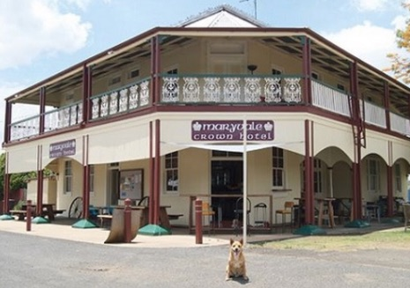

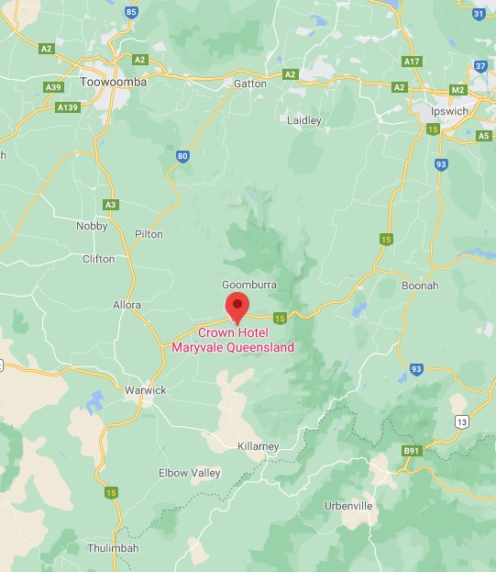

**Day 1 - August 2nd 2021**

Meet and greet from 11am for refreshments and complimentary pub lunch at Maryvale Crown Hotel, Main Street, Maryvale. The town is just off the Cumberland Highway taking you over the 'gap' in the Scenic Rim and most stunning part of the Great Dividing Range in south east Queensland. Get the sketchbooks out and have a wander around this outback town and following lunch we will proceed to our pick-up point for the retreat just a short drive away in time for check in at 2pm.

Afternoon will be used for orientation, sketching, painting, walking and exploring. We focus on painting and drawing directly from nature every day under the expert guidance of Idris.

Afternoon tea and dinner will be served in the main lodge. Times for all meals will be determined each day dependant on painting locations.

**Day 5 - August 6th 2021**

CHECK OUT REQUIRED BY 10AM

**Inclusions**

Individual tuition by renowned landscape artist and tutor, Idris Murphy

Informal evening discussion about artmaking

En Plein air painting each day with Idris

Painting demonstration and artist's critique

4xnights luxury twin share accommodation and glamping tent

pre-dinner nibbles by the firepit

3 meals per day3 meals

3 meals per day served in the lodge

morning and afternoon tea

bathroom amenities

all bedding

4WD transfer to and from parking to retreat

**exclusions**

Alcohol or other beverages

Art Materials

Travel Insurance